**WeRateDogs – Data Analysis**



WeRateDogs is a fun, humorous Twitter account that rate’s people’s dogs. It includes pictures, videos and humorous comments. Matt Nelson is credited for it’s creation. At the time, he was a college student and launched the account in 2015.

Today, WeRateDogs has over 8 million followers and is a wonderful site. It has inspired internet language with its classification of various dog stages. Words like “doggos” and “puppers” originated from this Twitter account, WeRateDogs. People enjoy the funny comments and cute photos of various dogs that people from all walks of life send in. It is reported that Matt receives 800 to 1,000 submissions daily. Of which, one is chosen for new dog content per day.

One must wonder how you can choose just one? Many followers of course want to share pictures and videos of their beloved pets. Also, it is fun to “Favorite” a post. This Twitter feature has changed but at the time period of this data set, Favorites were available and are comparable to Facebook’s “Likes”.



The Twitter Archieve included compiled data of “Favorites” and “Retweets”. “Retweets” are like sharing or reposting.Favorites could make your pet post very popular.The Twitter Archive included recorded Favorites and I did an analysis of Favorites over time.

The results were interesting.

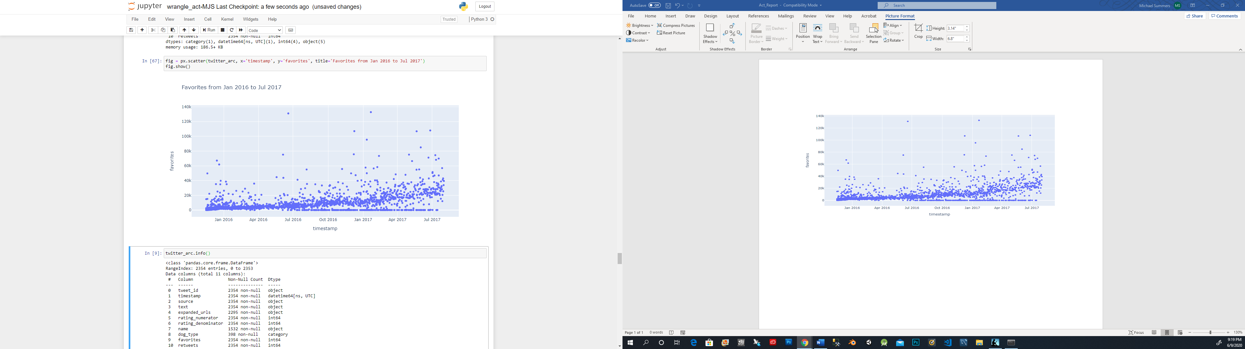

My analysis of the data set for Twitter account WeRateDogs reveal several interesting insights. First of all, the amount of “Favorites” votes has increased from 2016 to 2017. Proving this is a popular Twitter account with lasting appeal. We can visually see a few outliers over the time period. Significantly and random spikes in “Favorites” from post on WeRateDogs. Mostly, we can see from the above chart that “Favorites” were on the rise over time and seem steady. A good indication of an active and frequently visited web site.

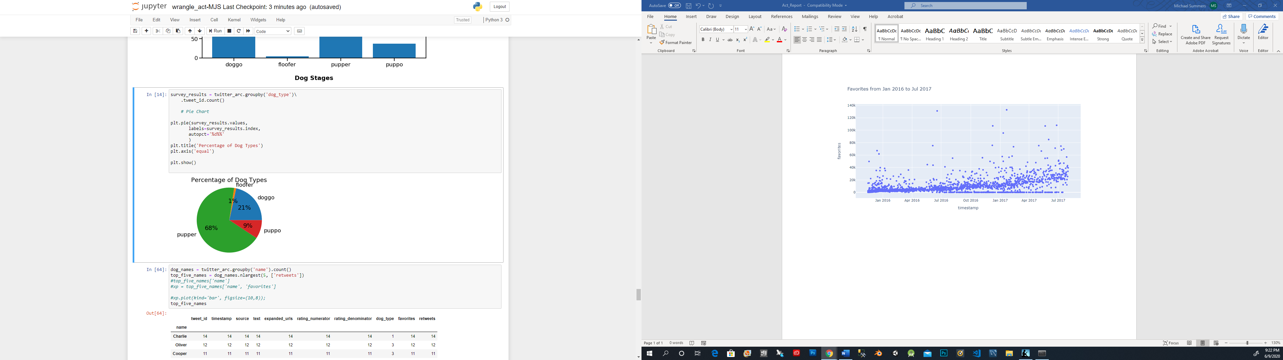

Next, I queried the data for a count of dog stages. The data revealed that the largest number per dog stage was “pupper”. Which is a small dog. Not yet considered a doggo in maturity level. The percentage of puppers is very high compared to the other recorded dog types. Pupper is 68% of entries in this dataset.

Next, I thought it would be interesting to find the most used dog “name” in this Twitter archieve data set. One, might imagine it would be Fito or Rover but the number one dog name is … Charlie.

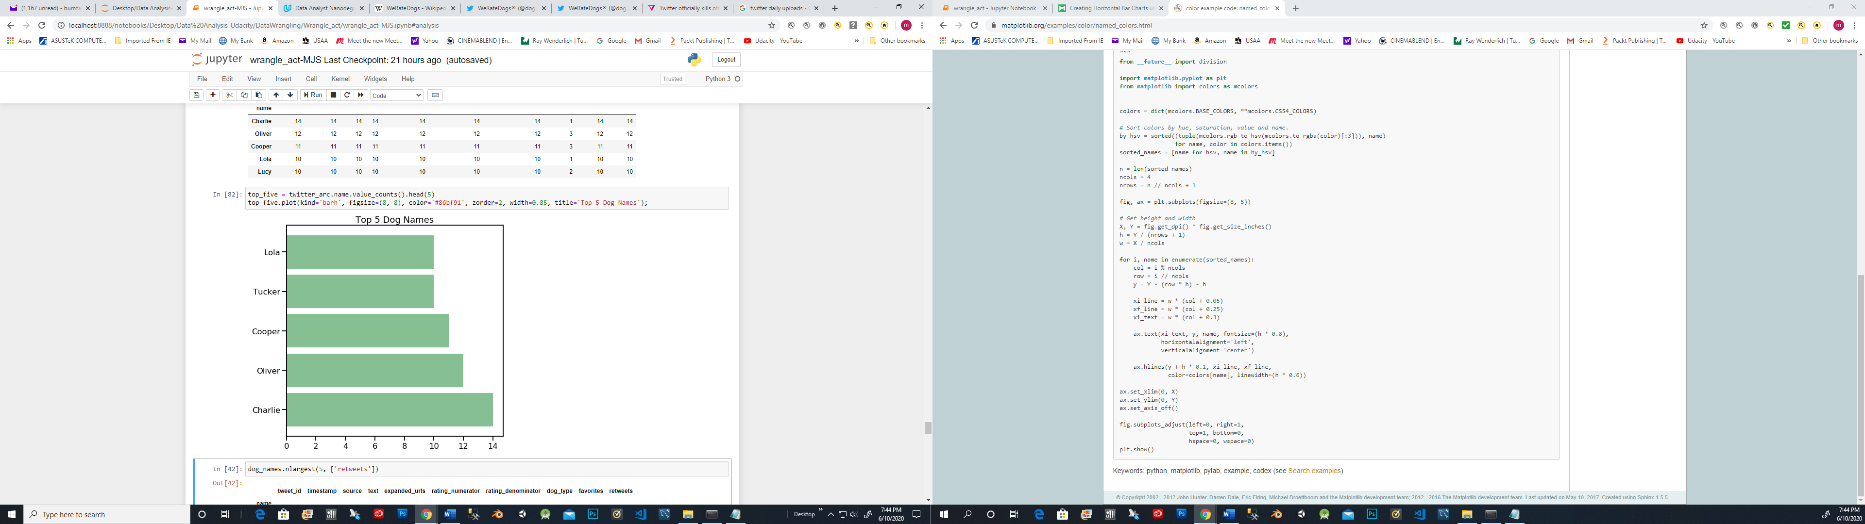

In conclusion, WeRateDogs is an amazing Twitter Account with high traffic volume. Exploring the data set was enjoyable. WeRateDogs has earned many achievements since its conception. Today, it has over 8 million followers. Also, WeRateDogs has merchandise, which includes a very popular Doggie calendar.

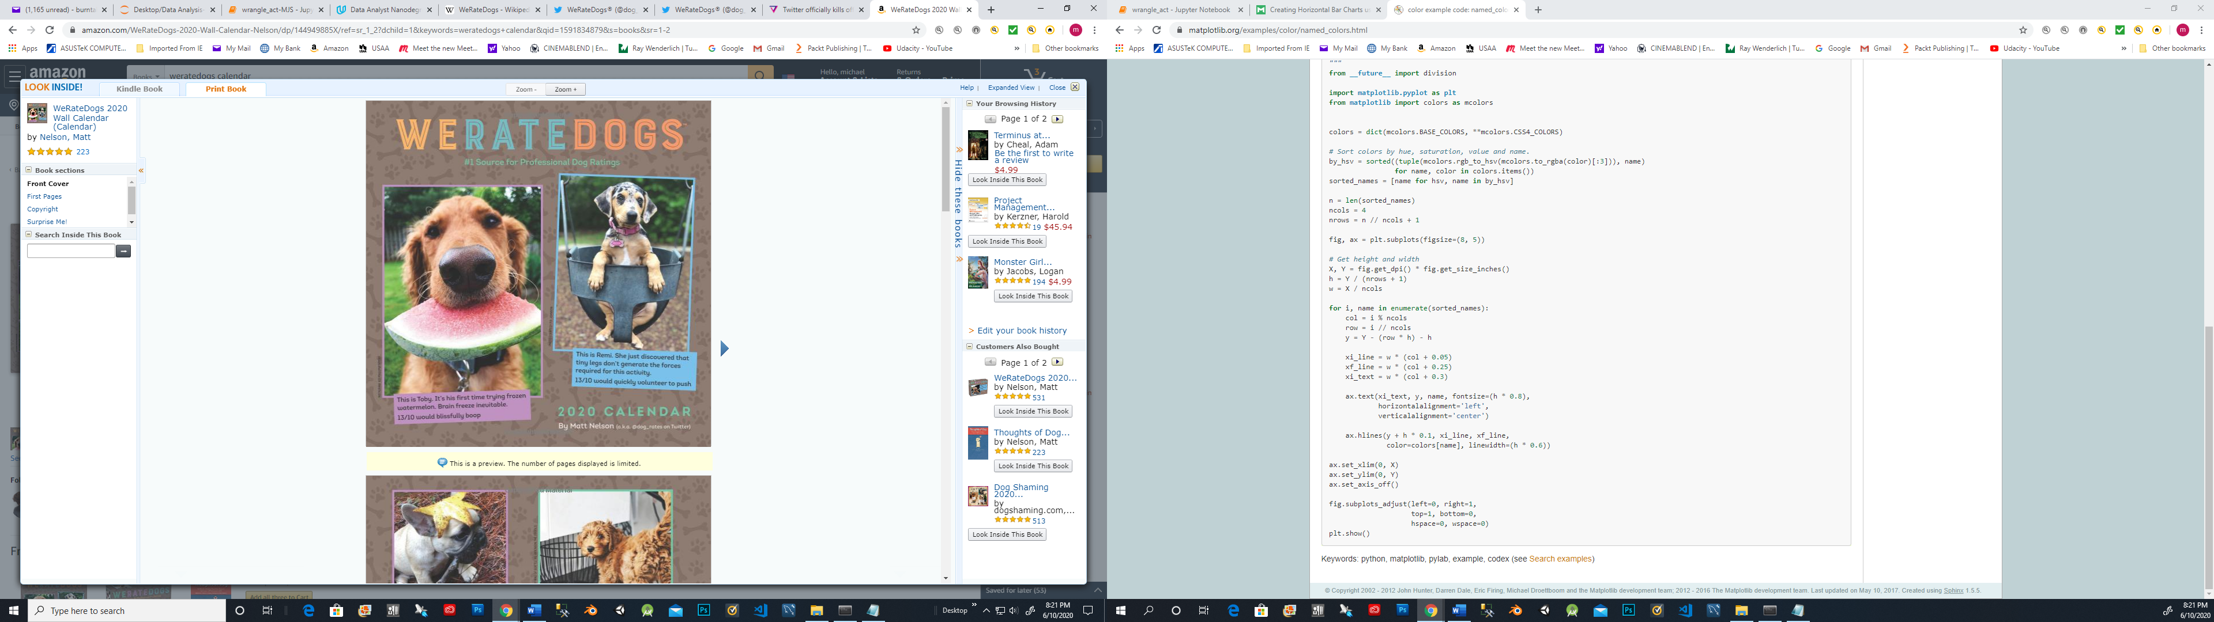

***“Bye-bye!”***



***Prepared by: Michael J. Summers***